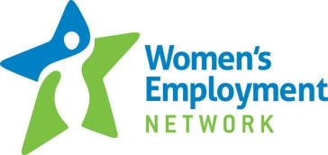
2014 Workshops
Open to the public

Goal Setting and Time Management
9am - 12noon June 25, August 6, September 17 and October 29
Workplace Etiquette
1pm - 4pm June 26, August 7, September 18, October 30
Problem Solving and Decision Making
1pm - 4pm June 30, August 11, September 22 and November 3
Basic Money Management
1pm - 4pm July 2, August 13, September 24 and November 5
Credit Reports and Identity Theft
1pm - 4pm July 17, August 28, October 9 and November 20

Please email your workshop selection(s) and date(s) to lwilliams@kcwen.org. If you are attending a workshop for the first time please arrive 30 minutes ahead of time to register.

